Myntra UI Automation Testing Documentation
Project Name
Myntra UI Automation
Website
https://www.myntra.com/
GitHub Link

Objective
To automate the search functionality of the Myntra website using Selenium WebDriver with Java and TestNG.
Tools & Technologies
- Java
- Selenium WebDriver
- TestNG
- Maven
- IntelliJ IDEA
- Chrome Browser
Project Structure
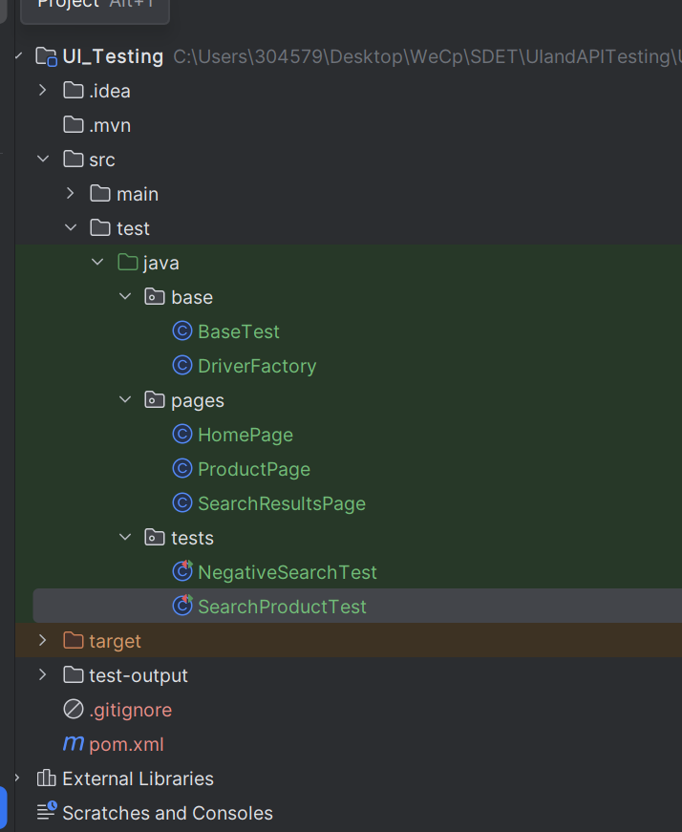
Locators Used
Element | Locator
Search Box | input.desktop-searchBar
Product List | product-base
First Product | (//li[contains(@class,'product-base')]//a)[1]
Brand Name | pdp-title
Product Name | pdp-name
Price | span.pdp-price strong

Assertions Performed
- Search results are displayed.
- Brand name is displayed.
- Product name is displayed.
- Product price is displayed.
- Product image is displayed.
- Page title contains product name.
- Product price is greater than zero.

Code:
Folder: Base
BaseTest.java

package base;
import org.openqa.selenium.WebDriver;
import org.testng.annotations.AfterMethod;
import org.testng.annotations.BeforeMethod;
public class BaseTest {
protected WebDriver driver;
@BeforeMethod
public void setup() {
driver = DriverFactory.getDriver();
driver.get("https://www.myntra.com/");
}
@AfterMethod
public void tearDown() {
if (driver != null) {
driver.quit();
}
}
}

DriverFactory.java

package base;
import java.time.Duration;
import org.openqa.selenium.WebDriver;
import org.openqa.selenium.chrome.ChromeDriver;
public class DriverFactory {
public static WebDriver getDriver() {
WebDriver driver = new ChromeDriver();
driver.manage().window().maximize();
driver.manage().timeouts().implicitlyWait(Duration.ofSeconds(10));
return driver;
}
}

Folder: Pages
HomePage.java
package pages;
import org.openqa.selenium.By;
import org.openqa.selenium.Keys;
import org.openqa.selenium.WebDriver;
public class HomePage {
private WebDriver driver;
public HomePage(WebDriver driver) {
this.driver = driver;
}
private By searchBox = By.cssSelector("input.desktop-searchBar");
public void searchProduct(String product) {
driver.findElement(searchBox).clear();
driver.findElement(searchBox).sendKeys(product);
driver.findElement(searchBox).sendKeys(Keys.ENTER);
}
}

ProductPage.java

package pages;
import org.openqa.selenium.By;
import org.openqa.selenium.WebDriver;
public class ProductPage {
WebDriver driver;
public ProductPage(WebDriver driver) {
this.driver = driver;
}
private By brandName = By.className("pdp-title");
private By productName = By.className("pdp-name");
private By price = By.cssSelector("span.pdp-price strong");
public boolean isBrandDisplayed() {
return driver.findElement(brandName).isDisplayed();
}
public boolean isProductNameDisplayed() {
return driver.findElement(productName).isDisplayed();
}
public boolean isPriceDisplayed() {
return driver.findElement(price).isDisplayed();
}
public boolean isImageDisplayed() {
return driver.getPageSource().contains("<img");
}
public String getProductName() {
return driver.findElement(productName).getText();
}
public String getPageTitle() {
return driver.getTitle();
}
public int getPrice() {
String amount = driver.findElement(price).getText();
amount = amount.replace("₹", "").replace(",", "").trim();
return Integer.parseInt(amount);
}
}

SearchResultsPage.java

package pages;
import org.openqa.selenium.By;
import org.openqa.selenium.WebDriver;
public class SearchResultsPage {
WebDriver driver;
public SearchResultsPage(WebDriver driver) {
this.driver = driver;
}
private By products = By.className("product-base");
private By firstProduct = By.xpath("(//li[contains(@class,'product-base')]//a)[1]");
public boolean isSearchResultsDisplayed() {
return driver.findElements(products).size() > 0;
}
public void clickFirstProduct() {
driver.findElement(firstProduct).click();
}
public int getProductCount() {
return driver.findElements(products).size();
}
}

Test Scenario 1 - Search Product
Steps
- Launch Myntra website.
- Search for "Shoes".
- Verify search results are displayed.
- Open the first product.
- Verify Brand Name.
- Verify Product Name.
- Verify Product Price.
- Verify Product Image.
- Verify page title contains the product name.
- Verify product price is greater than zero.
Positive test:

SearchProductTest.java
package tests;
import static org.testng.Assert.assertTrue;
import org.testng.annotations.Test;
import base.BaseTest;
import pages.HomePage;
import pages.ProductPage;
import pages.SearchResultsPage;
public class SearchProductTest extends BaseTest {
@Test
public void verifyProductDetails() throws InterruptedException {
HomePage home = new HomePage(driver);
SearchResultsPage results = new SearchResultsPage(driver);
home.searchProduct("Shoes");
assertTrue(results.isSearchResultsDisplayed());
results.clickFirstProduct();
String parent = driver.getWindowHandle();
for (String window : driver.getWindowHandles()) {
if (!window.equals(parent)) {
driver.switchTo().window(window);
break;
}
}
Thread.sleep(3000);
ProductPage product = new ProductPage(driver);
assertTrue(product.isBrandDisplayed());
assertTrue(product.isProductNameDisplayed());
assertTrue(product.isPriceDisplayed());
assertTrue(product.isImageDisplayed());
assertTrue(product.getPageTitle().contains(product.getProductName()));
assertTrue(product.getPrice() > 0);
}
}

Test Scenario 2 - Invalid Search
Steps
- Launch Myntra website.
- Search for "nameofthegameisnone".
Results : no products should be displayed
Negative test:
package tests;
import static org.testng.Assert.assertFalse;
import org.testng.annotations.Test;
import base.BaseTest;
import pages.HomePage;
import pages.SearchResultsPage;
public class NegativeSearchTest extends BaseTest {
@Test
public void verifyInvalidSearch() {
HomePage home = new HomePage(driver);
SearchResultsPage results = new SearchResultsPage(driver);
home.searchProduct("nameofthegameisnone");
assertFalse(results.isSearchResultsDisplayed());
}
}

Execution
Commands used:
- Run all the test cases
mvn clean test
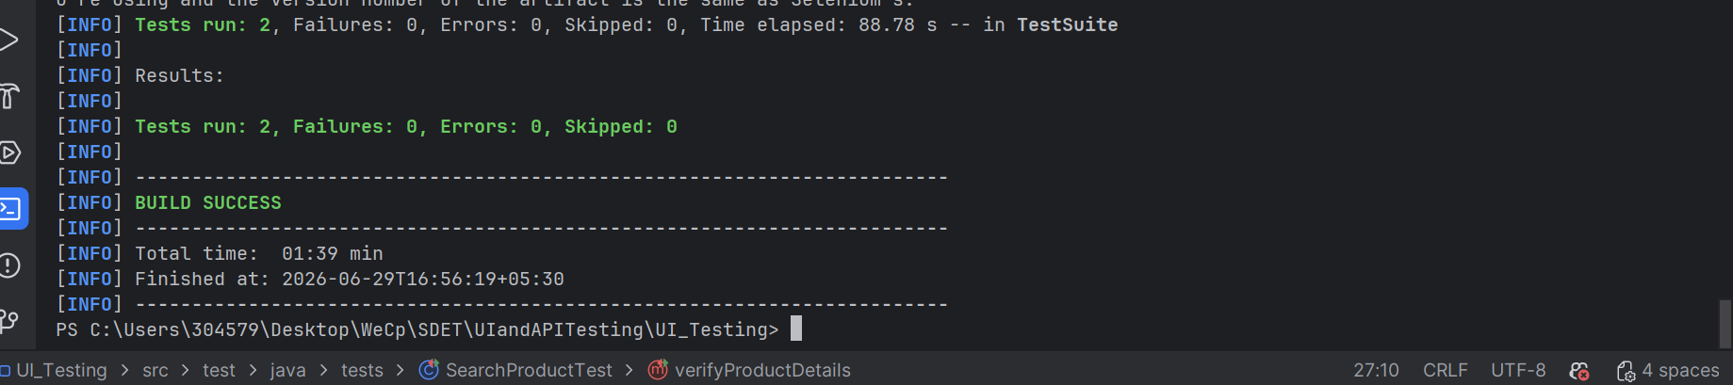
- SearchProductTest (positive)
mvn test -Dtest=SearchProductTest
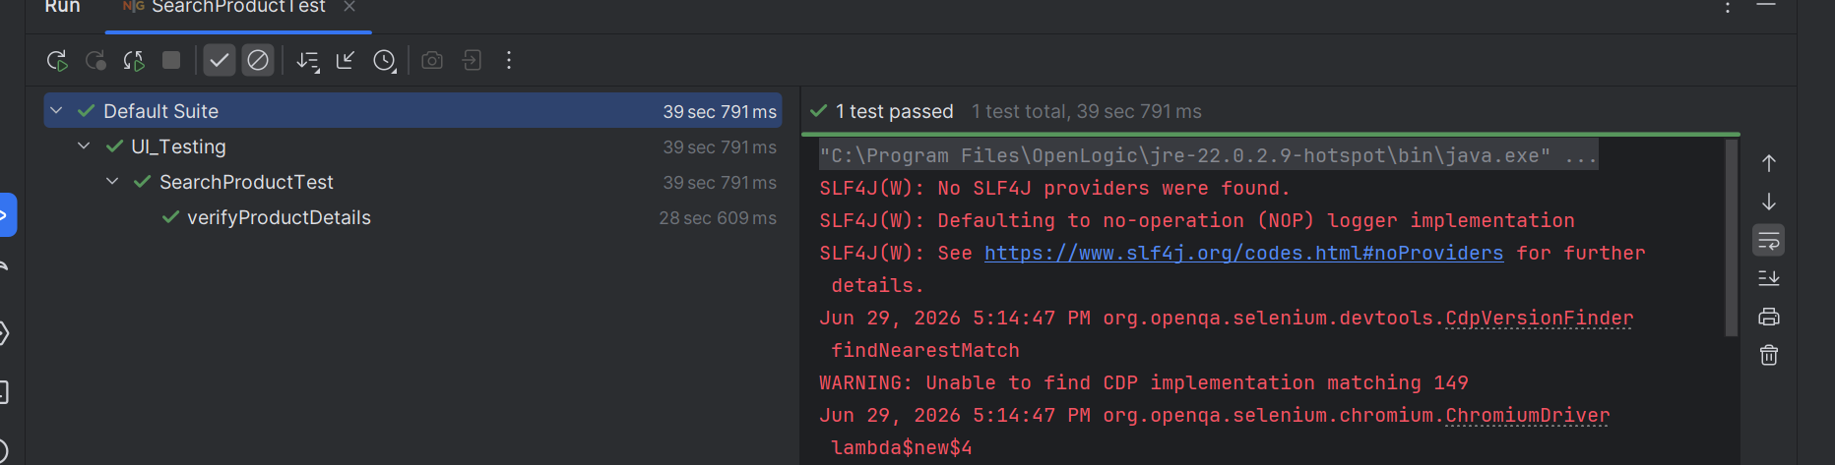
- NegativeSearchTest(negative)
mvn test -Dtest=NegativeSearchTest
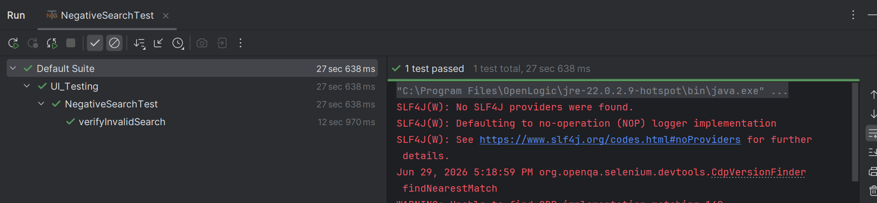
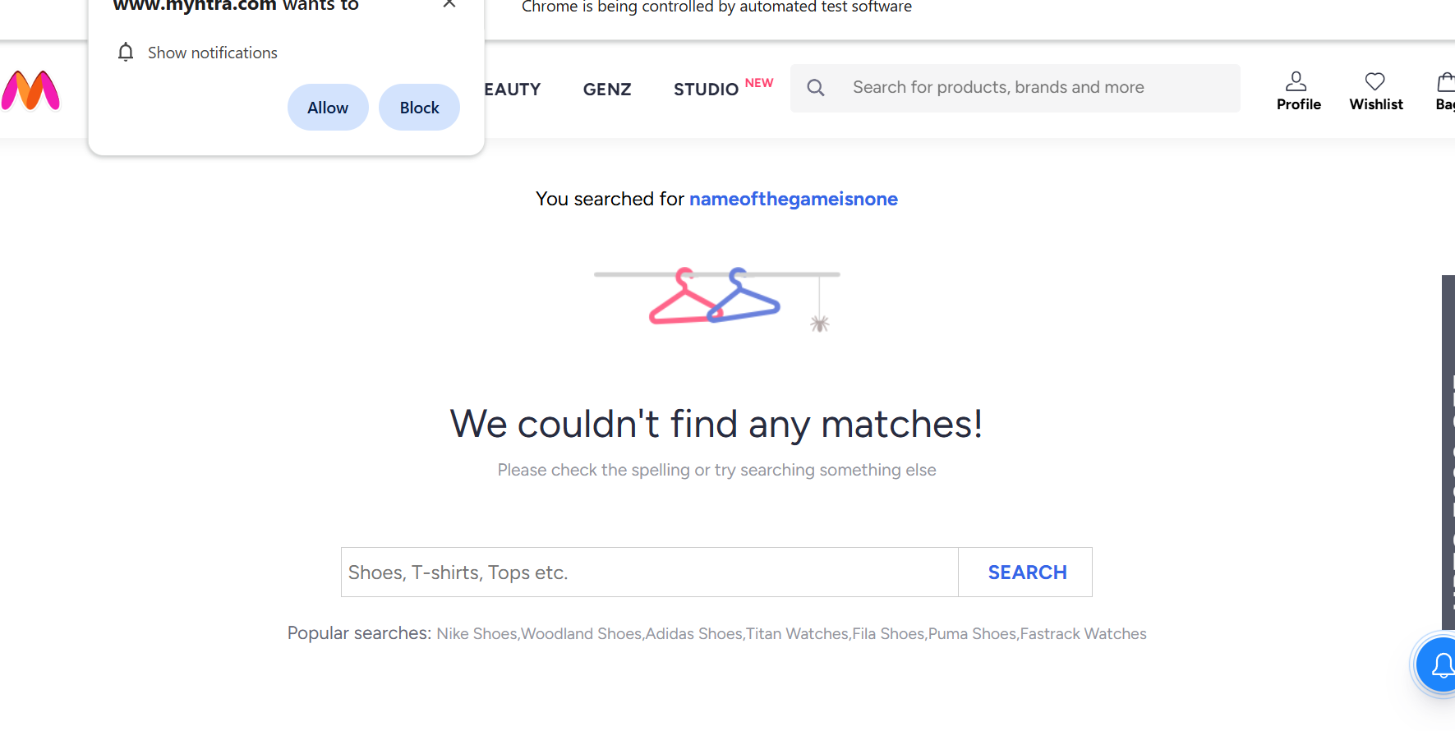
- To run in headed mode
mvn clean test -Dheadless=false
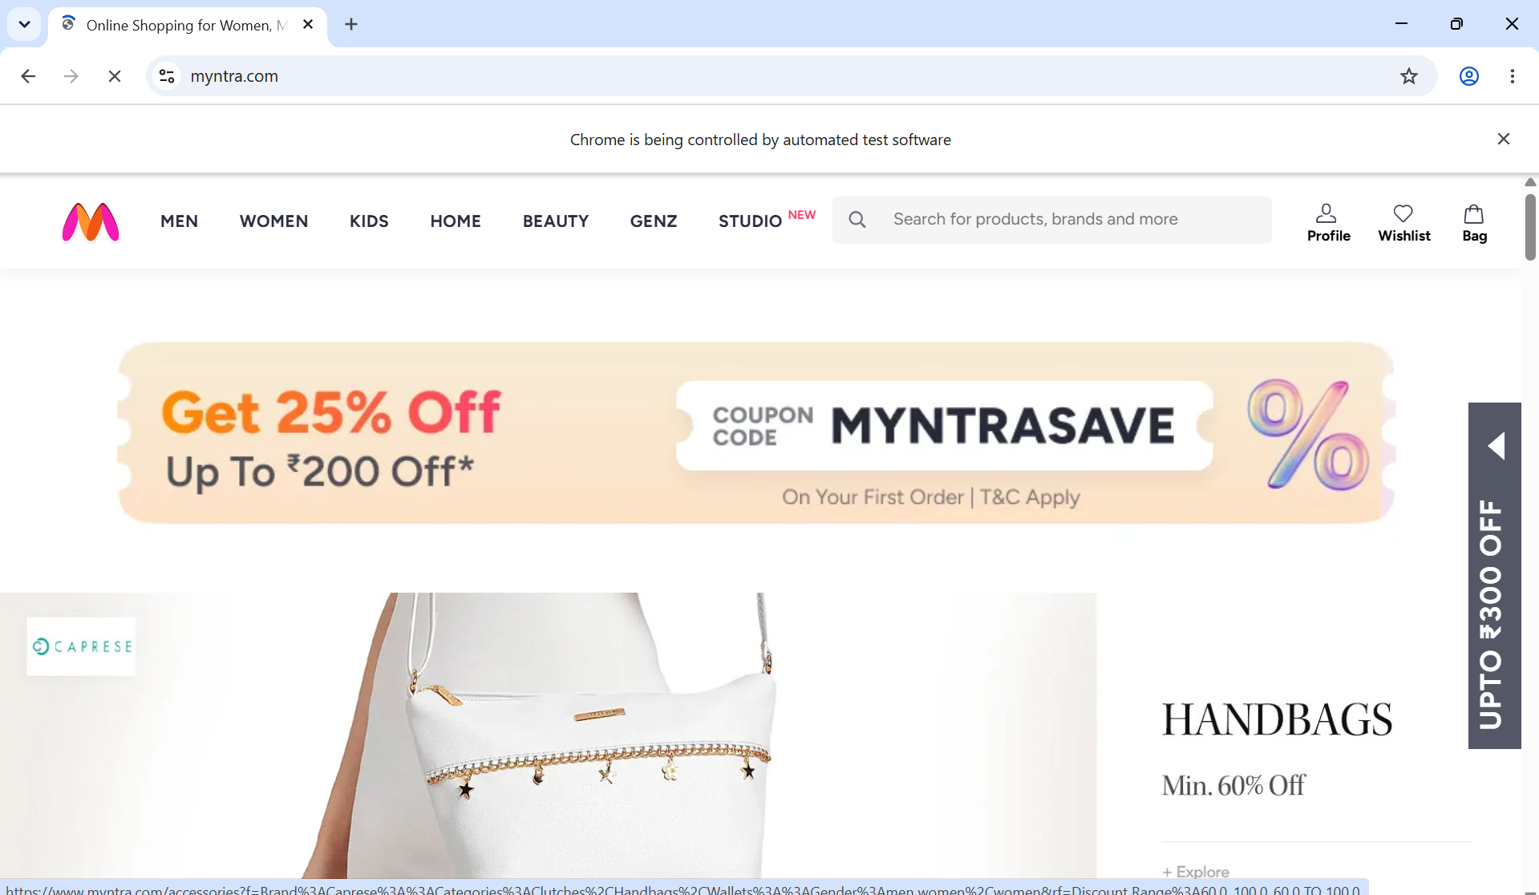
- Ro run in headless mode
mvn clean test -Dheadless=true

Outcome
The automation validates the product search functionality, verifies product details, and checks the application's behavior for an invalid search query using Selenium WebDriver.

